GRAPH DATABASE

**ABSTRACT**

This report presents an in-depth analysis of a comprehensive dataset of over 5,000 movies from IMDb, examining various factors such as budget, rating, and profitability. The data was stored in Neo4j and processed using a combination of queries and visualizations. The analysis identified key findings such as the highest grossing and highest/lowest rated movies (including the actors and directors associated with them), the most successful genre, the movie with the highest number of critic reviews, the directors with the most number of movies, and those who directed the highest budget movies between 2009 and 2013. The study also includes CRUD operations performed in the databases, with Python used for analysis.In addition, the report discusses the use of containerization and orchestration in Neo4j. Overall, this analysis provides valuable insights into trends and preferences in the movie industry, allowing for a deeper understanding of the factors that contribute to a movie's success.

Top of Form

Bottom of Form

**Cleaning the dataset using python:**

* The jupyter notebook file will be uploaded.
* All the null values are removed
* The genre column is split into multiple columns with Boolean values

**Data Model for the IMDB dataset:**

We have created three nodes namely: actor, movie_title and director and the properties are as follows:

* Movie_title: id, title, title_year, imdb_rating, budget, gross, duration, number of reviews by critics and number of reviews by users
* Actor:id, name, actor_facebook_likes, id
* Director: director_facebook_likes,name id

The relationship between actor and movie_title is “acted_in” as many actors can be a part of many movies and a movie is directed by a director, the relationship between movie_title and director is directed by-from movie_title to director.

**Creating three nodes and relationships:**

**Query:**

LOAD CSV WITH HEADERS FROM "file:///imdb.csv" AS row

MERGE (m:Movie {title: row.movie_title})

ON CREATE SET m.duration = toInteger(row.duration),

m.director_name = row.director_name,

m.imdb_score = toFloat(row.imdb_score),

m.title_year = toInteger(row.title_year),

m.num_critic_for_reviews = toInteger(row.num_critic_for_reviews),

m.num_user_for_reviews = toInteger(row.num_user_for_reviews),

m.budget = toFloat(row.budget),

m.gross = toFloat(row.gross)

MERGE (a:Actor {name: row.actor_1_name})

ON CREATE SET a.actor_facebook_likes = toInteger(row.actor_1_facebook_likes)

MERGE (m)-[:ACTS_IN]->(a)

MERGE (d:Director {name: row.director_name})

ON CREATE SET d.director_facebook_likes = toInteger(row.director_facebook_likes)

MERGE (d)-[:DIRECTED]->(m)

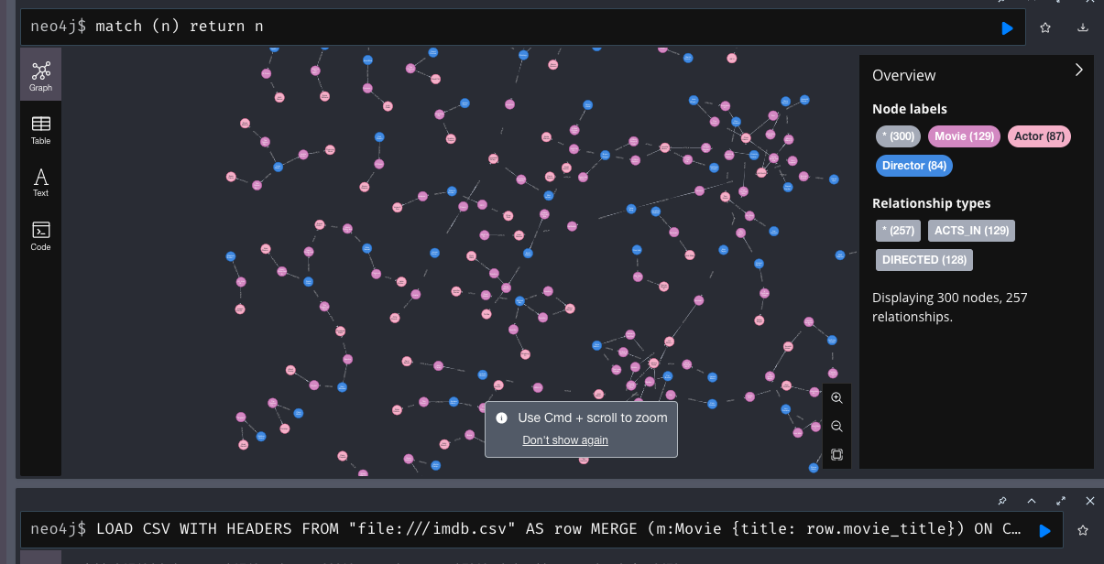

**Adding a node:**

CREATE (m:Movie {title: 'The Matrix', title_year: 1999, imdb_rating: 8.7})

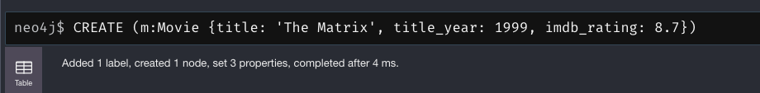

**Adding a relationship:**

MATCH (m:Movie {title: 'The Matrix'})

MATCH (a:Actor {name: 'Keanu Reeves'})

MERGE (a)-[:ACTS_IN]->(m)

MATCH (a:Actor)-[r:ACTS_IN]->(m:Movie {title: 'The Matrix'}) RETURN a, r, m

**Updating a node:**

MATCH (m:Movie {title: 'The Matrix'}) SET m.title_year = 1998

MATCH (m:Movie {title: 'The Matrix'})

RETURN m

**Deleting a node with the movie_title “Quantum_of_solace”**

MATCH (m:Movie {title: 'Quantum of Solace'})

DETACH DELETE m

**Checking if the node still exists:**

MATCH (m:Movie {title: 'Quantum of Solace'})

RETURN m

**QUERIES:**

**1.Top 10 highest grossing movies:**

**QUERY:**

MATCH (m:Movie)WHERE toInteger(m.gross) IS NOT NULL

RETURN DISTINCT m.title, toInteger(m.gross)

ORDER BY toInteger(m.gross) DESC

**2.Query to show the profit of the movies each year**

**QUERY:**

MATCH (m:Movie)

WHERE toInteger(m.gross) IS NOT NULL AND toInteger(m.budget) IS NOT NULL AND toInteger(m.title_year) IS NOT NULL

WITH m, toInteger(m.gross) - toInteger(m.budget) AS profit

RETURN m.title_year AS title_year, sum(profit) AS total_profit

ORDER BY title_year

**3.Top 5 highest IMDB rating movies**

**QUERY:**

MATCH (m:Movie)

WHERE m.imdb_score IS NOT NULL

RETURN m.title, m.imdb_score

ORDER BY m.imdb_score DESC

LIMIT 5

**4.Top 5 years which had the highest budget:**

**QUERY:**

MATCH (m:Movie)

WHERE m.budget IS NOT NULL AND m.title_year IS NOT NULL

WITH m.title_year AS year, SUM(m.budget) AS total_budget

RETURN year, total_budget

ORDER BY total_budget DESC

LIMIT 5

**5.The name of the movie with the highest number of critic reviews and its profit:**

**QUERY:**

MATCH (m:Movie)

WHERE m.num_user_for_reviews IS NOT NULL AND m.num_critic_for_reviews IS NOT NULL

RETURN m.title AS movie_title, m.num_critic_for_reviews AS critic_reviews, (toInteger(m.gross)-toInteger(m.budget)) AS movie_profit

ORDER BY m.num_critic_for_reviews DESC

LIMIT 1

**6.Name of the directors who have directed the highest budget movie from year 2009-2013:**

**QUERY:**MATCH (d:Director)-[:DIRECTED]->(m:Movie)

WHERE m.title_year >= 2009 AND m.title_year <= 2013 AND m.budget IS NOT NULL

WITH d, m

ORDER BY m.budget DESC

RETURN d.name AS director_name, m.title AS movie_title, m.budget AS movie_budget

LIMIT 5

**7.The top 5 directors who have directed the most number of movies and their imdb ratings;**

**QUERY:**

MATCH (d:Director)-[:DIRECTED]->(m:Movie)

WITH d, count(m) AS num_movies, avg(m.imdb_score) AS avg_score

ORDER BY num_movies DESC

LIMIT 5

RETURN d.name, num_movies, avg_score

**CONTAINERIZATION**

**Running the database in a container:**

This command creates a new container named "testneo4j" with Neo4j database running inside it. The container is configured to use the CSV file located at "/Users/poojamanjunatha/Desktop/imdb.csv" as the data source for Neo4j's import tool.

**The container is visible:**

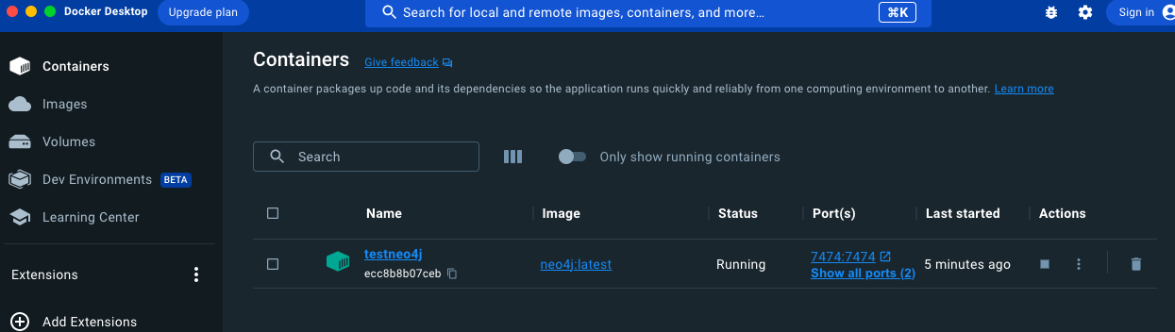

**Database creation:**

**All the nodes and relationships are created:**

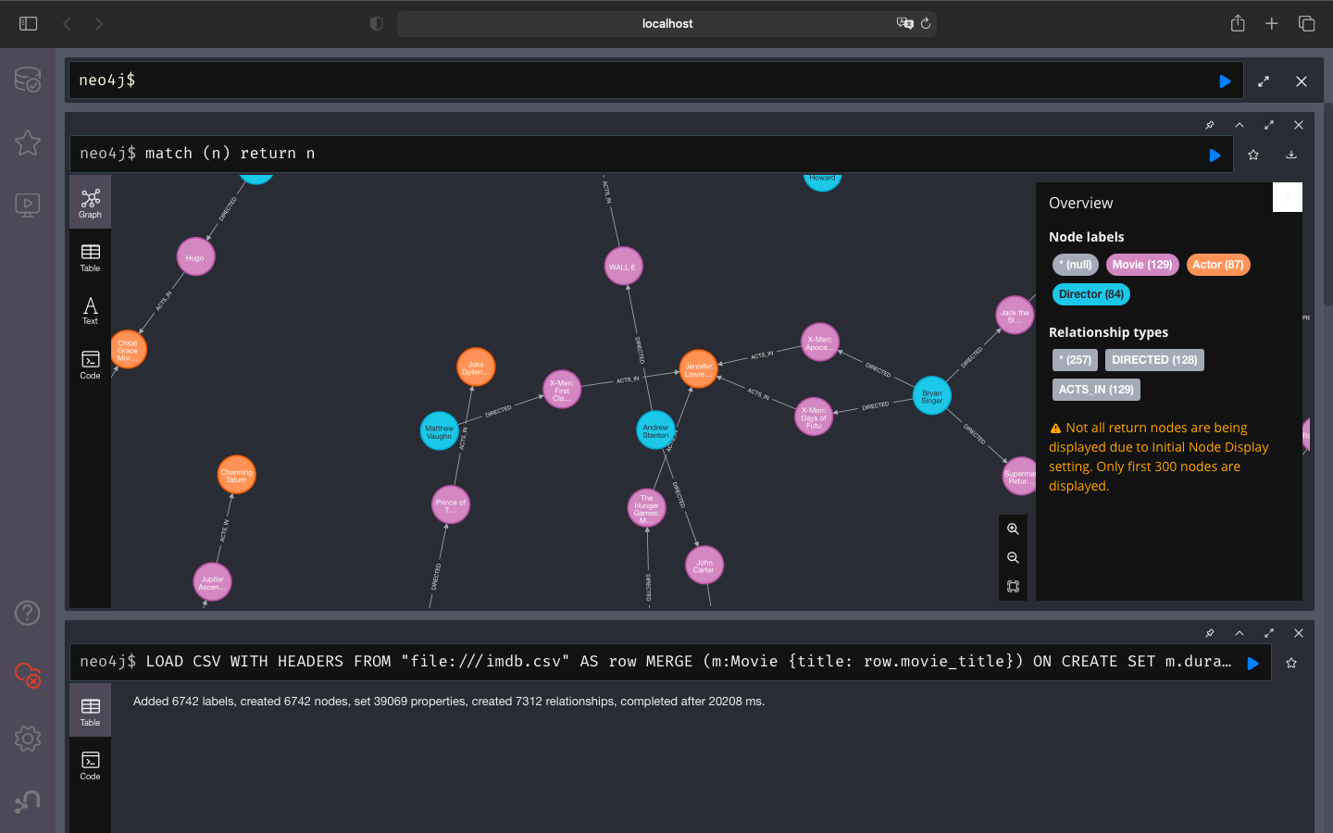

**ORCHESTRATION:**

**Docker Swarm:**

**Getting the IP address of the container created above**

docker inspect -f '{{range .NetworkSettings.Networks}}{{.IPAddress}}{{end}}' $(docker ps -q --filter "name=neo4j")



**Creating a swarm node:**

docker swarm init --advertise-addr 172.17.0.2

**Creating a .yml file:**

**Deployment:**

This command deploys a new stack called my-stack using the my-docker-compose.yml file as the configuration for the services. It creates a new network named my-stack_default and a new service called my-stack_database based on the configuration in the compose file. The my-stack_database service will use the neo4j image and will be deployed as a single replica on the manager node.



**This is a Docker Compose file that defines a service called "neo4j". The service is based on the "neo4j:latest" Docker image**

**This command shows the number of replicas:**





**Accessing the Neo4j web interface running in a container by opening a web browser and navigate to** [**http://192.168.86.28:7474**](http://192.168.86.28:7474)

